- Installations
Installed Kali linux from https://www.kali.org/

Installed Metasploitable3 from https://sourceforge.net/projects/metasploitable3-ub1404upgraded/
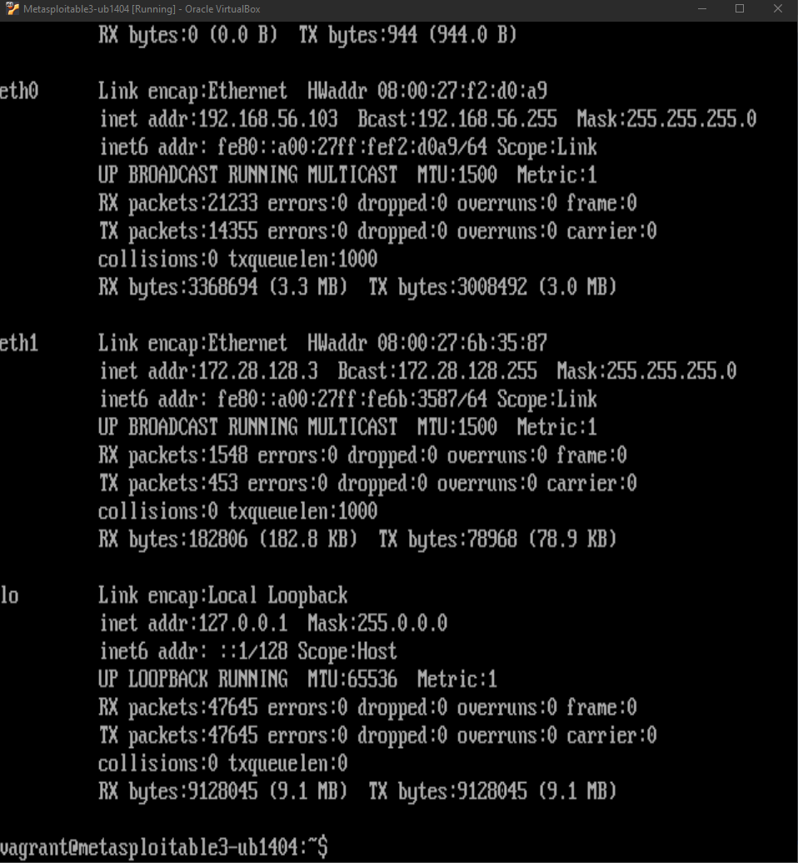
Note that the victim IP is 192.168.56.103

Ensured the connectivity using ping
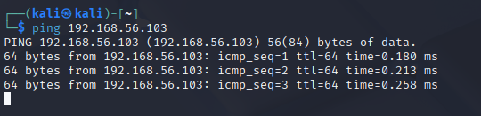
- Compromising the Service Using Metasploit
  - Scan for Vulnerabilities
Used Nmap to scan open ports
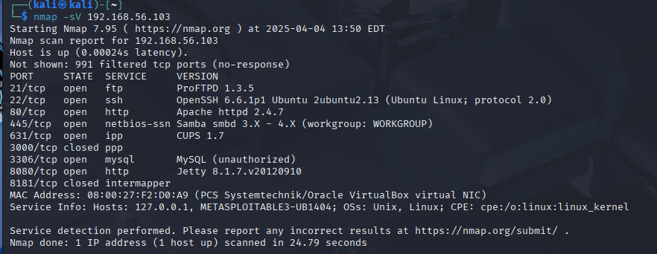
chose to exploit SSH

  - Use Kali Linux tool Metasploit to compromise the service.
Used brute force from a predefined list attached in the repo
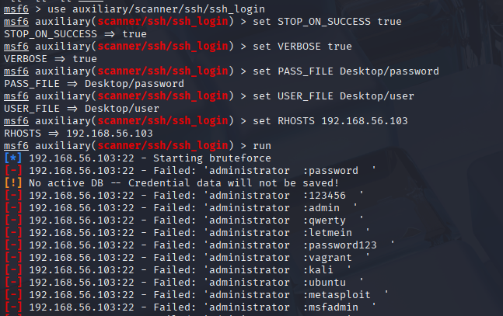
Till we get a valid credentials which is vagrant:vagrant

Then we can enter the session and have access to the victim device

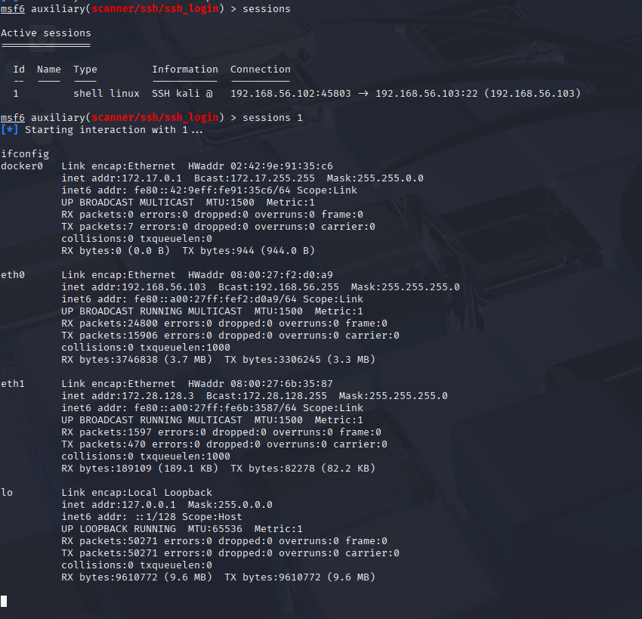
We can get all user accounts:
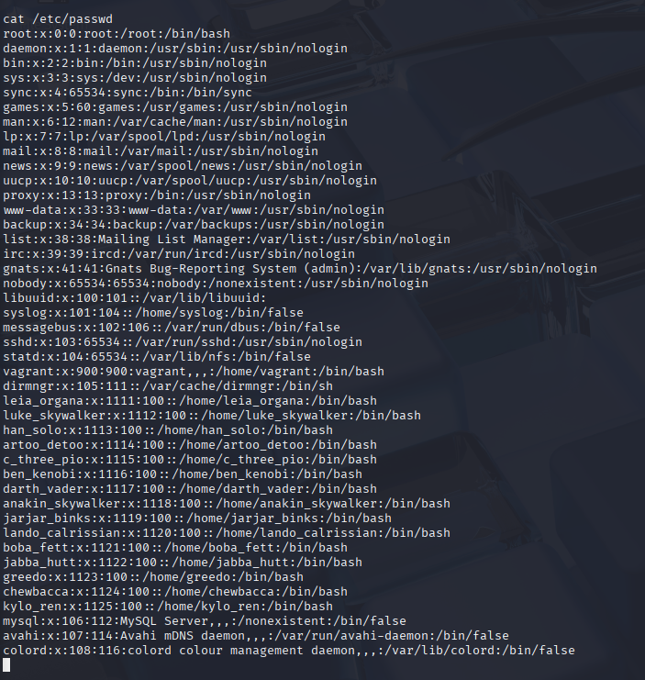
Show SSH authorized keys:

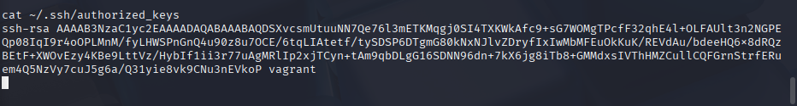
Create files
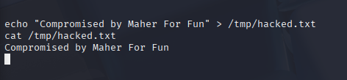

  - Compromising SSH using a custom script

We used a Python script with the paramiko library to perform the brute-force SSH attack, upload a file, and verify its presence on the victim machine. The script was set up to try common username and password combinations and then upload a file upon successful login.

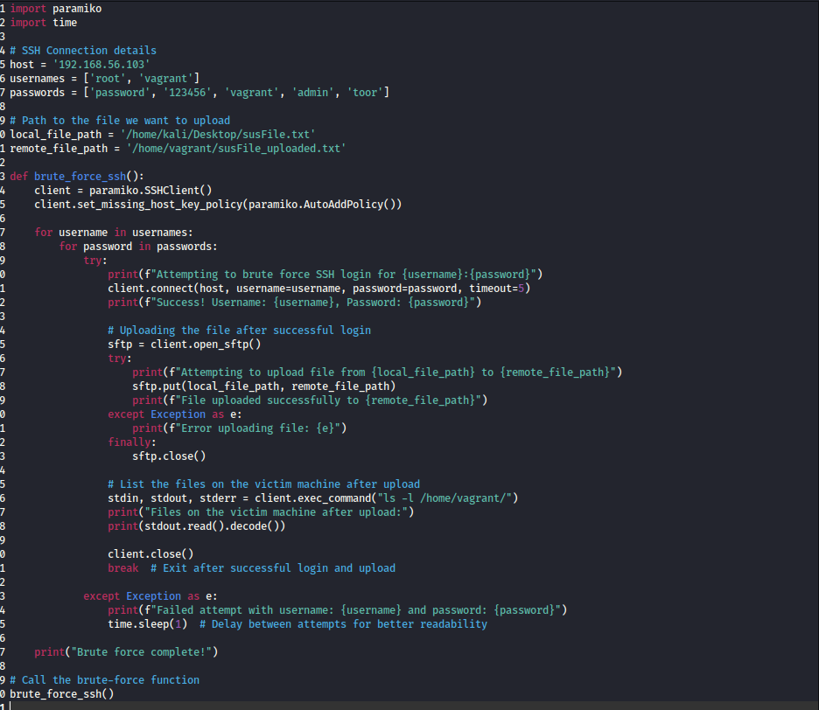

Using the script, we attempted to brute-force the SSH login using combinations of usernames (root, vagrant) and passwords (password, 123456, etc.). After several failed attempts, the correct credentials vagrant:vagrant were found, allowing us to gain access to the victim machine.

The file susFile.txt was selected for upload to the victim machine. Once SSH access was gained, the file was uploaded using paramiko's SFTP functionality.

After the file was uploaded, the script executed the ls -l /home/vagrant/ command to list the files on the victim machine. The output confirmed that the uploaded file susFile_uploaded.txt was successfully placed in the directory.
Com
